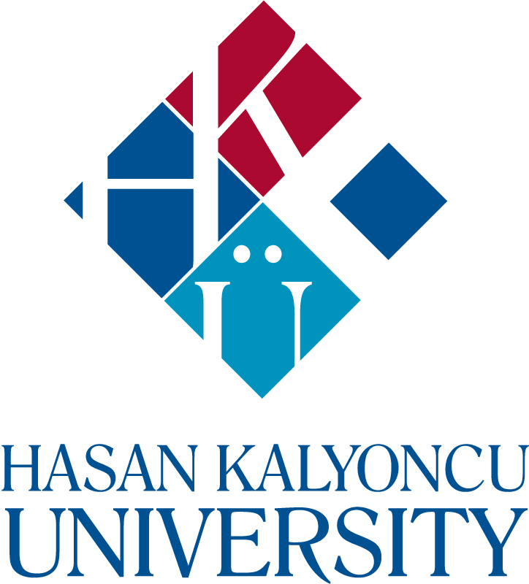

**THE 5TH INTERNATIONAL AFRICA CONFERENCE**

***CONFERENCE PROGRAM***

**- APRIL 30, 2025 -**

African Studies Applications and Research Center

Migration, Population, Education and Employment Problems Applications and Research Center

Development Studies Applications and Research Center

|  |  |  |
| --- | --- | --- |
| **PROGRAM SCHEDULE** | | |
| **OPENING SPEECHES**  **(*In-person and Online*)** | **VENUE: HUKUK AMFİ** | **30.04.2025**  **TIME: 10.00-10.45** |
| **10.00-10.15** | Protocol Opening Speeches | |
| **10.15-10.25** | **Asst. Prof. Dr. Pelin ALİYEV**  Hasan Kalyoncu University  *Department of Political Science and International Relations &*  *African Studies Applications and Research Center* | |
| **10.25-10.35** | **Prof. Dr. Cenker Korhan DEMİR**  Hasan Kalyoncu University  *Department of Political Science and International Relations &*  *Migration, Population, Education and Employment Problems Applications and Research Center* | |
| **10.35-10.45** | **Prof. Dr. Mehmet Hanifi ASLAN**  Hasan Kalyoncu University  *Department of Economics & Development Studies Applications and Research Center* | |
| ***Link:***  <https://zoom.us/w/98635389296?tk=UfKmkszPqxevYQMcQ57biZHdfHGLLwCJ5fggCpHvPxE.DQcAAAAW9yCZcBZnN3E3VFdVYVRRV09aOGtxMVl6SlpBAAAAAAAAAAAAAAAAAAAAAAAAAAAAAAAAAAAAAAA>  ***Code:*** 986 3538 9296 | | |

**10.45-11.00 TEA/COFFEE BREAK**

|  |  |  |  |
| --- | --- | --- | --- |
| **SESSION-1**  **(*In-person and Online*)** | **DATE: 30.04.2025**  **TIME: 11.00-12.00**  **VENUE: HUKUK AMFİ**  **PRESENTATION LANGUAGE: TURKISH** | **UNIVERSITY** | **TITLE** |
| **11.00-11.05** | Prof. Dr. Ahmet KESER *Moderator* | Hasan Kalyoncu University, Türkiye | - |
| **11.05-11.15** | Prof. Dr. Ercan SEYHAN | Hasan Kalyoncu University, Türkiye | Batı Afrika’da Sınır Aşan ve Organize Suç Olgusu |
| **11.15-11.25** | Assoc. Prof. Dr. Zeynep KÖSE | Hasan Kalyoncu University, Türkiye | Afrika’da İklim Adaleti: En Az Katkı, En Fazla Etki |
| **11.25-11.35** | Asst. Prof. Dr. Burçin ULUĞ & MA Student Pınar OKATAN | Hasan Kalyoncu University, Türkiye | Çin’in Afrika Stratejisi: Dinamikler, Fırsatlar ve Zorluklar |
| **11.35.11.45** | PhD Cand. Gül ÇELİK & Assoc. Prof. Dr. Ömer Faruk RENÇBER | Gaziantep University, Türkiye | Finansal Sürdürülebilirlik ve Ekonomik Performans: Çok Kriterli Karar Verme Yöntemleriyle Entegre Bir Analiz |
| **11.45-11.55** | Undergraduate Student Eren YİĞİTOĞLU | Ankara Hacı Bayram Veli University, Türkiye | M23 (23 Mart) Hareketi |
| **11.55-12.00** | Q/A | | |
| ***Link:***  <https://zoom.us/w/98635389296?tk=UfKmkszPqxevYQMcQ57biZHdfHGLLwCJ5fggCpHvPxE.DQcAAAAW9yCZcBZnN3E3VFdVYVRRV09aOGtxMVl6SlpBAAAAAAAAAAAAAAAAAAAAAAAAAAAAAAAAAAAAAAA>  ***Code:*** 986 3538 9296 | | | |

**ONLINE SESSIONS**

|  |  |  |  |
| --- | --- | --- | --- |
| **SESSION-2** | **DATE: 30.04.2025**  **TIME: 13.00-14.00**  **PRESENTATION LANGUAGE: TURKISH** | **UNIVERSITY** | **TITLE** |
| **Session Chair** | Asst. Prof. Dr. Pelin ALİYEV | Hasan Kalyoncu University, Türkiye | - |
| **13.05-13.15** | Dr. Tunç DEMİRTAŞ | SETA, Türkiye | Türkiye’nin Afrika’da Arabuluculuk Vizyonu: Ankara Süreci Örneği Üzerinden Bir Değerlendirme |
| **13.15-13.25** | Asst. Prof. Dr. Cihan DABAN | Mersin University, Türkiye | Bir Devrimin Öncüsü: Burkina Faso’da Thomas Sankara Örneği |
| **13.25-13.35** | Dr. Hasan AYDIN | Shangai University, China | Çin-Afrika Sağlık İşbirliğinde FOCAC Etkisi: Gine Cumhuriyeti’nde 2014 Ebola Salgını Örneği |
| **13.35-13.45** | PhD Cand. Gözde SÖĞÜTLÜ | Istanbul University, Türkiye | Sudan İç Savaşı: Türkiye’nin Arabuluculuk Diplomasisi |
| **13.45-13.55** | Assoc. Prof. Dr. Emre SAYGIN | Eskişehir Osmangazi University, Türkiye | Afrika’nın Ekonomik Güvenlik Riski: Borç Tuzağı Diplomasisi Hegemonik Bir İlluzyon mu? |
| **13.55-14.00** | Q/A | | |
| ***Link:***  <http://oys.hku.edu.tr/JoinMeeting?organizationid=fa473839-6e41-40cb-a98c-f43429aa6145&meetingid=5e5fe83a-9314-4718-a84c-fcdac65559d5> | | | |

|  |  |  |  |
| --- | --- | --- | --- |
| **SESSION-3** | **DATE: 30.04.2025**  **TIME: 13.00-14.00**  **PRESENTATION LANGUAGE: TURKISH** | **UNIVERSITY** | **TITLE** |
| **Session Chair** | Asst. Prof. Dr. Fırat Cem Doğan | Hasan Kalyoncu University, Türkiye |  |
| **13.05-13.15** | MA Student Muhammet Cuma TIRAŞÇI | Hasan Kalyoncu University, Türkiye | Fildişi Sahili’nde Sürdürülebilir Kalkınmaya Yönelik Zorluklar ve Fırsatlar |
| **13.15-13.25** | MA Student Ahmet Burak BAYKUŞ & Asst. Prof. Dr. Pelin ALİYEV | Hasan Kalyoncu University, Türkiye | İnsani Güvenlik Perspektifinden Türkiye-Somali İlişkilerinin Analizi |
| **13.25-13.35** | Assoc. Prof. Dr. Erdem ÖZLÜK & MA Student Silale SAIDE | Selçuk University, Türkiye | Mozambique’s Struggle with Terrorism: Regional Instability and International Engagement |
| **13.35-13.45** | M. Sc. Vildan DERİNCE & Prof. Dr. Mehmet Hanifi ASLAN | Hasan Kalyoncu University, Türkiye | Afrika Kıtasal Serbest Ticaret Bölgesi Anlaşması (AfCFTA) ve Ekonomik Kalkınma: Eğilimler, Zorluklar ve Gelecek Perspektifleri |
| **13.45-13.55** | MA Student Gözdehan ALTINKAYNAK | Hasan Kalyoncu University, Türkiye | Demokratikleşme, Güvenlik ve Kalkınma İlişkisi: Gana Örneği |
| **13.55-14.00** | Q/A | | |
| ***Link:***  <http://oys.hku.edu.tr/JoinMeeting?organizationid=fa473839-6e41-40cb-a98c-f43429aa6145&meetingid=3908bf28-5308-4b91-bd28-9266e43e9d02> | | | |

|  |  |  |  |
| --- | --- | --- | --- |
| **SESSION-4** | **DATE: 30.04.2025**  **TIME: 13.00-14.00**  **PRESENTATION LANGUAGE: TURKISH** | **UNIVERSITY** | **TITLE** |
| **Session Chair** | Assoc. Prof. Dr. Zeynep KÖSE | Hasan Kalyoncu University, Türkiye | - |
| **13.05-13.15** | PhD. Cand. Mahir ATAY | University of Carthage, Tunisia | Tunus’ta Habib Bourguiba Dönemindeki Kadın Hakları Kazanımlarının Tunus Demokratikleşmesine Etkisi |
| **13.15-13.25** | Dr. Neslihan KURAN | - | Afrika’dan Bir Dış Göç Hareketi: Yahudi Oldukları İddiasıyla İsrail’e Yerleştirilen Afrikalılar |
| **13.25-13.35** | Asst. Prof. Dr. Habibe TEMİZSU | Bingöl University, Türkiye | İmparatorluğa İman: Cecil Rhodes’un Amentüsü |
| **13.35-13.45** | Lecturer Dr. Hande SAPMAZ | Mardin Artuklu University, Türkiye | Afrika’da Bölgesel Kalkınmanın Karşısında Toprak Gaspı: Toprak Adaleti Kuramı Çerçevesinden Güney Kamerun Üzerine Bir İnceleme |
| **13.45-13.55** | Dr. Emine Zeynep DABAN | Akdeniz University, Türkiye | İngiltere Sömürgeciliğine Karşı Afrika’da Yerli Direnişi: Mzee Jomo Kenyatta Liderliğinde Kenya Örneği |
| **13.55-14.00** | Q/A | | |
| ***Link:***  <http://oys.hku.edu.tr/JoinMeeting?organizationid=fa473839-6e41-40cb-a98c-f43429aa6145&meetingid=5ddf3c9a-41c2-4ff5-950d-3a261393e2d4> | | | |

|  |  |  |  |
| --- | --- | --- | --- |
| **SESSION-5** | **DATE: 30.04.2025**  **TIME: 13.00-14.00**  **PRESENTATION LANGUAGE: ENGLISH** | **UNIVERSITY** | **TITLE** |
| **Session Chair** | Asst. Prof. Dr. Mehmet ÖNDER | Hasan Kalyoncu University, Türkiye | - |
| **13.05-13.15** | Assoc. Prof. Dr. Erdem KILIÇ | Turkish-German University, Türkiye | Economic Integration and Monetary Prospects in BRICS+: The Role of African Member States |
| **13.15-13.25** | Dr. Ramel KHEDIDJA | University of Algiers, Algeria | The Implications of the Grand Ethiopian Renaissance Dam (GERD) on Egypt’s Water Security |
| **13.25-13.35** | Research Fellow Laurette TETERO & Dr. Öğr. Üyesi Bekir HALHALLI | University of Kyrenia, TRNC | From Ethnic Conflicts to Peace: Burundi’s Road to Stability in East Africa |
| **13.35-13.45** | Asst. Prof. Dr. Mehmet ÖNDER | Hasan Kalyoncu University, Türkiye | Perceptions of Democracy Within the Middle East and North Africa |
| **13.45-13.55** | MA Student Shamil ELFAKI | Ankara Social Sciences University, Türkiye | UAE’s Strategic Engagement in Africa: A Focus on the Horn of Africa and Countering the Influence of the Muslim Brotherhood |
| **13.55-14.00** | Q/A | | |
| ***Link:***  <http://oys.hku.edu.tr/JoinMeeting?organizationid=fa473839-6e41-40cb-a98c-f43429aa6145&meetingid=2d629c53-8aac-42b0-8a04-6e9bdaa373f9> | | | |

|  |  |  |  |
| --- | --- | --- | --- |
| **SESSION-6** | **DATE: 30.04.2025**  **TIME: 15.00-16.10**  **PRESENTATION LANGUAGE: ENGLISH/FRENCH** | **UNIVERSITY** | **TITLE** |
| **Session Chair** | Asst. Prof. Dr. Pelin ALİYEV | Hasan Kalyoncu University, Türkiye | - |
| **15.05-15.15** | Assoc. Prof. Dr. Murat ASLAN | Hasan Kalyoncu University, Türkiye | UN Reform: Why and How? |
| **15.15-15.25** | Undergraduate Student Şaziye Sıla AYDIN | Hasan Kalyoncu University, Türkiye | Migration Movements in Africa From A World Systems Theory Perspective |
| **15.25-15.35** | MA Student Mahmoud ALBASHA | Hasan Kalyoncu University, Türkiye | Interlinkages Between Migration, Conflict, and Violent Extremism in Niger |
| **15.35-15.45** | PhD Cand. Göktuğ ÇALIŞKAN | International University of Rabat, Morocco | The Crime Economy, Jihadist Organizations, and the Development Crisis in Mali: Local Dynamics and Global Implications |
| **15.45-15.55** | MA Student Ganime ÖZKAN & MA Student Mine GÖKKAYA | Hasan Kalyoncu University, Türkiye | The Nexus Between Migration and Conflict in Burkina Faso |
| **15.55-16.05** | Dr. Frederick MBA MISSANG | Université Omar Bongo, Gabon | Afrique: Construire l’Etat démocratique avec l’armée |
| **16.05-16.10** | Q/A | | |
| ***Link:***  <http://oys.hku.edu.tr/JoinMeeting?organizationid=fa473839-6e41-40cb-a98c-f43429aa6145&meetingid=31bba484-875f-4d83-9758-43f16dd729e5> | | | |

**In case you encounter any problems, it is kindly requested that you contact Research Assistant Engin Can BEYAZIT through the communication channels listed below so that we can assist you.**

*Contact Information:*  
[karmer@hku.edu.tr](mailto:karmer@hku.edu.tr)   
+90 541 295 80 32